**SAVEETHA SCHOOL OF ENGINEERING**

**SAVEETHA INSTITUTE OF MEDICAL AND TECHNICAL SCIENCES**

**INSTITUTE OF PLACEMENT AND TRAINING**

**CSA09 –JAVA PROGRAMMING**

**Name:SUSHEEL**

**Reg.No:192325007**

**Course:CSA-0987**

**ASSIGNMENT - 1**

**String**

1. Write a program to reverse a word using loop? (Not to use inbuilt functions) Sample Input: String: TEMPLE Sample Output:

Reverse String: ELPMET

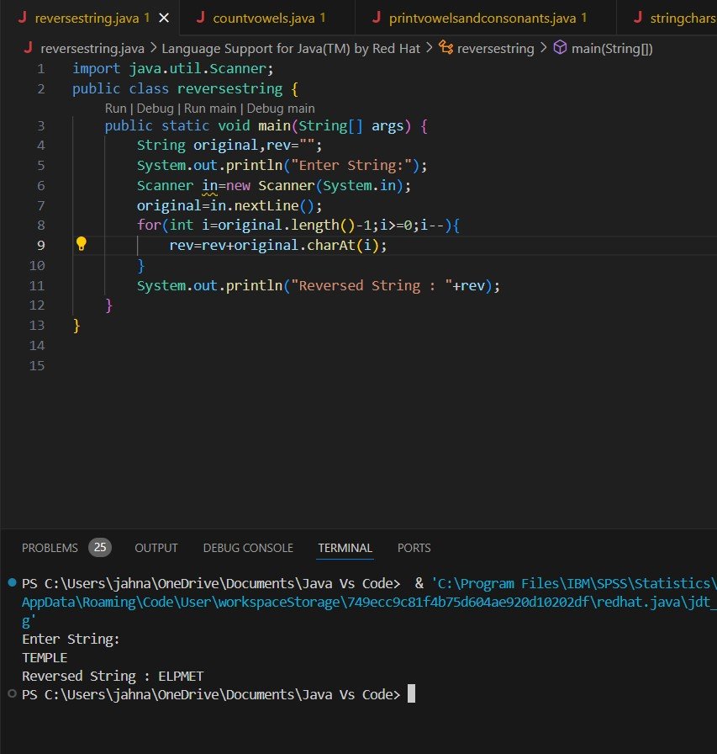

1. Write a program to convent the given string to integer?

Sample Input:

String: 1234

Sample Output:

Out put String: 1234

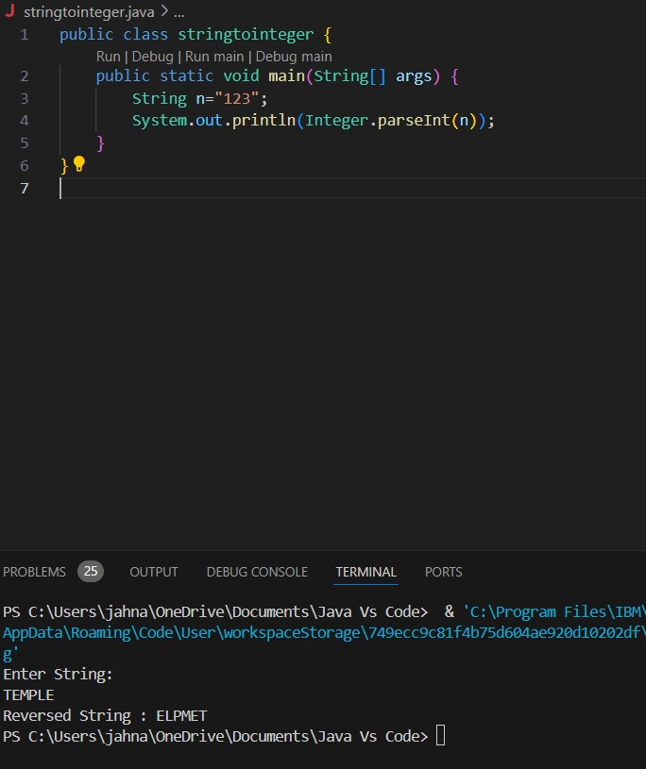

1. Write a program to check the entered user name is valid or not. Get both the inputs from the

user.

CODE:

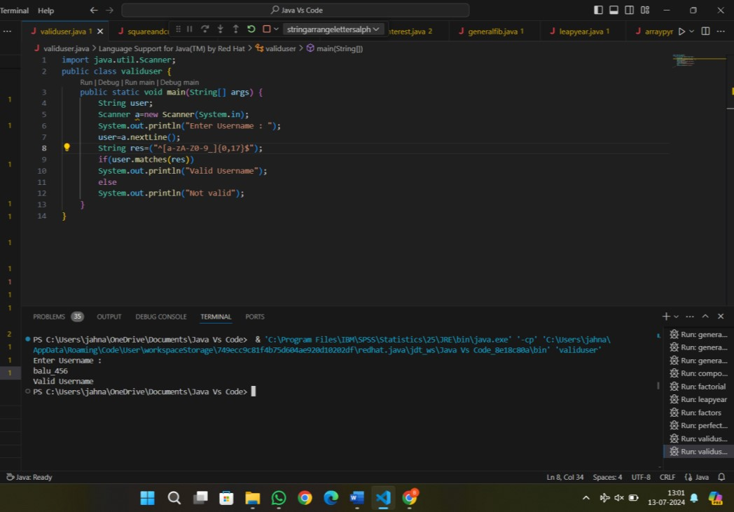

1. Write a program that would sort a list of names in alphabetical order Ascending or Descending, choice get from the user? Sample Input:

Banana

Carrot

Radish

Apple

Jack Order(A/D) : A Sample Output:

Apple

Banana

Carrot

Jack

Radish

OUTPUT:

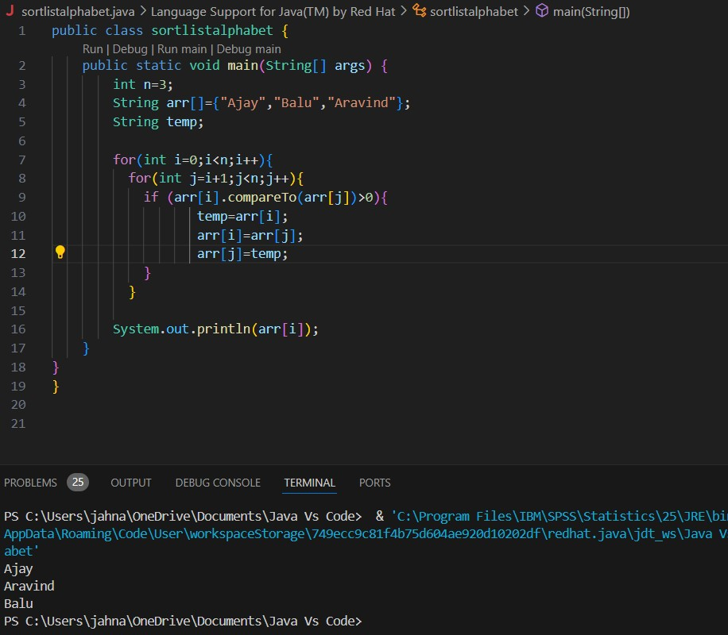

1. Write a program to print the special characters separately and print number of Special characters in the line?

OUTPUT:

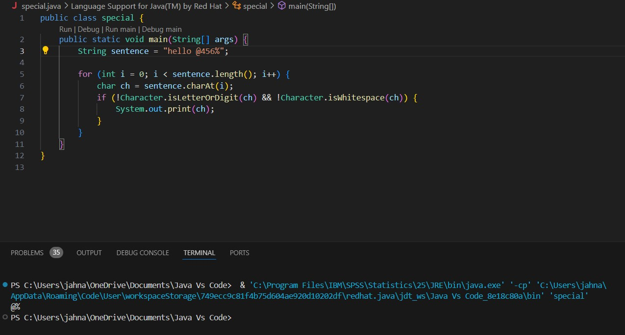

1. Write a program to print the number of vowels in the given statement?

Sample Input:

Saveetha School of Engineering Sample Output:

Number o vowels = 12 OUTPUT:

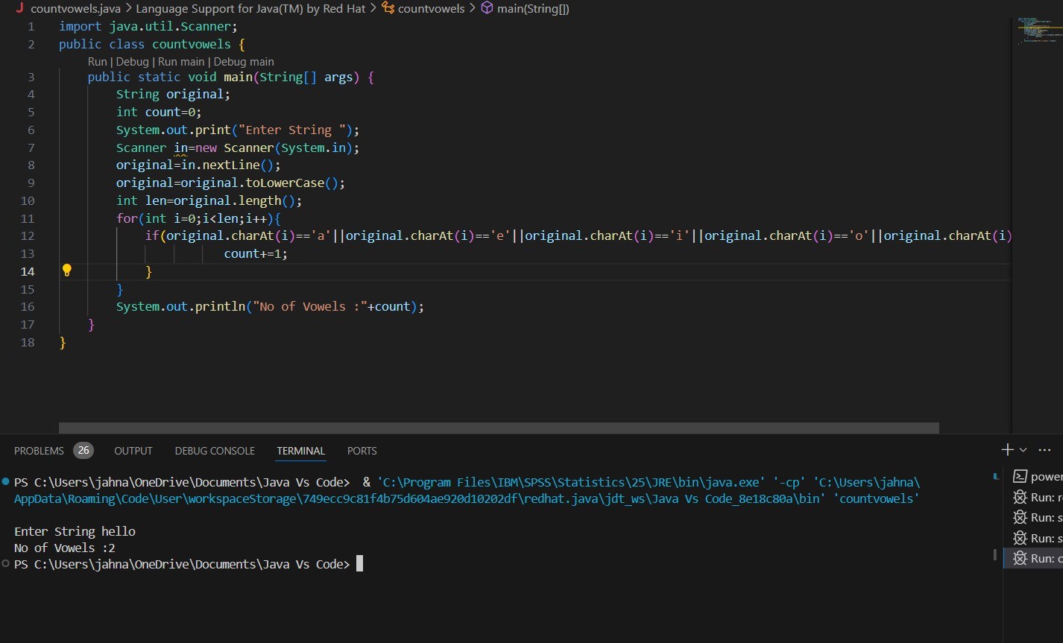

1. Write a program to print consonants and vowels separately in the given word Sample Input:

Given Word: Engineering Sample Output:

Consonants: n g n r n g

Vowels: e i e ei

OUTPUT:

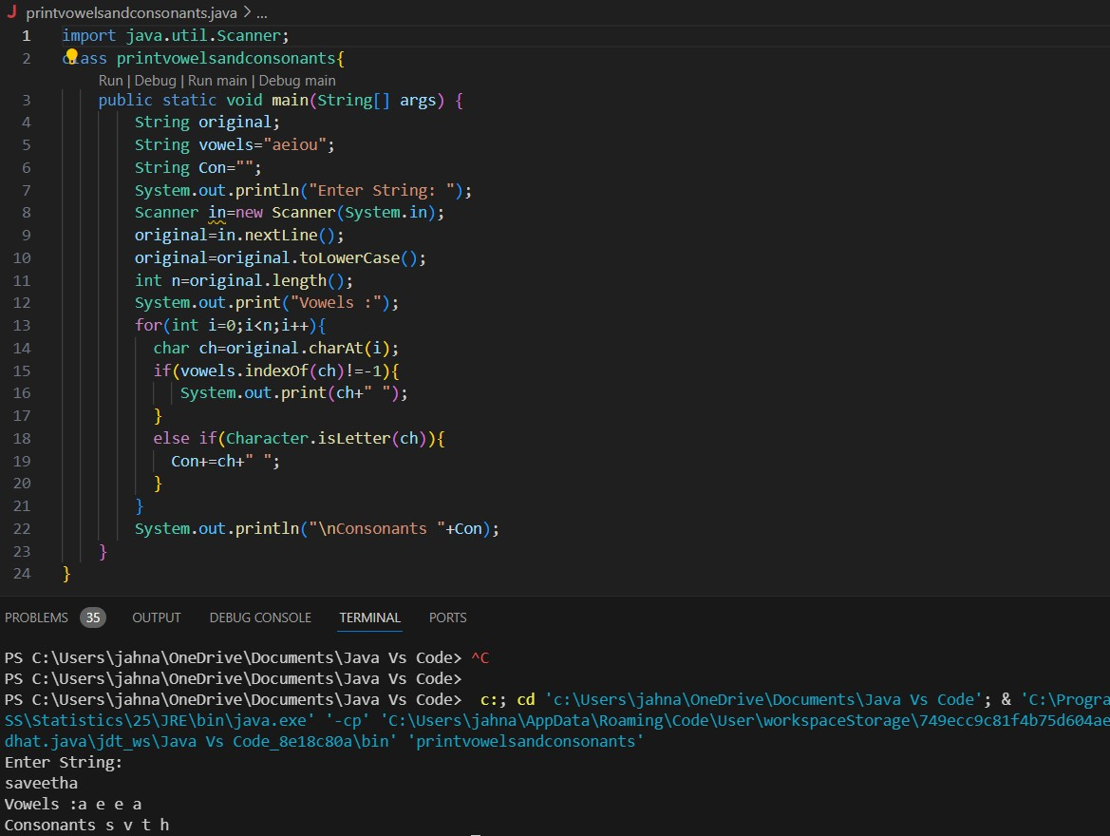

1. Write a program that finds whether a given character is present in a string or not. In case it is present it prints the index at which it is present. Do not use built-in find functions to search the character. Sample Input:

Enter the string: I am a programmer Enter the character to be searched: p Sample Output:

P is found in string at index: 8

Note: Check for non available Character in the given statement as Hidden Test case.

OUTPUT:

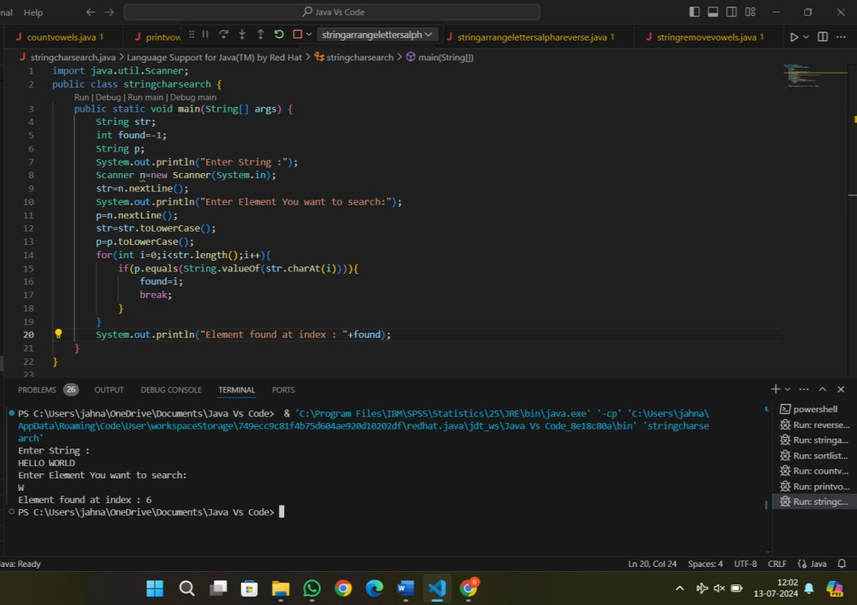

1. Write a program to arrange the letters of the word alphabetically in reverse order Sample Input:

Enter the word: MOSQUE Sample Output:

Alphabetical Order: U S Q O M E Test Case:

1. HYPOTHECATION

# 2. MATRICULATION

# 3. MANIPULATION

OUTPUT:

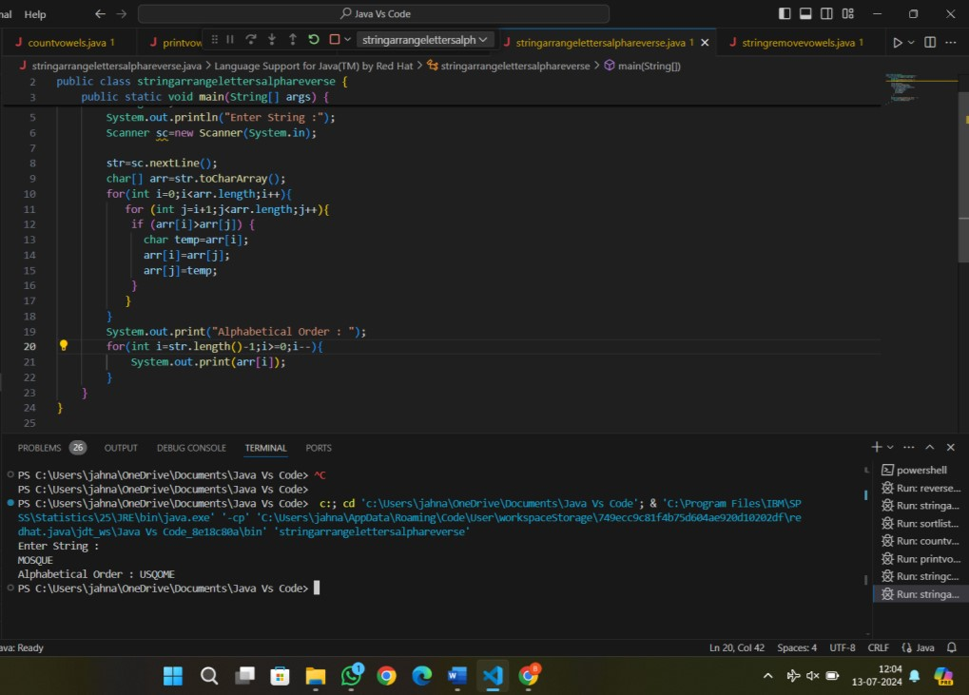

1. Write a program that accepts a string from user and displays the same string after removing vowels from it. Sample Input & Output:

Enter a string: we can play the game

The string without vowels is: w cn ply thgm

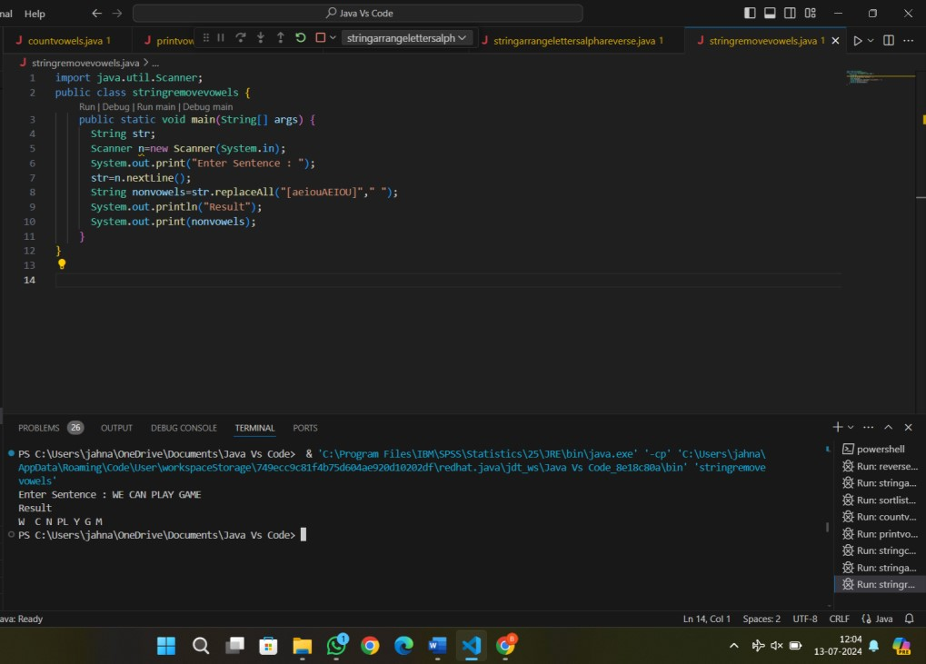

**ASSIGNMENT-2**

1. Write a program for matrix multiplication?

Sample Input:

Mat1 = 1 2

5 3

Mat2 = 2 3

4 1

Sample Output:

Mat Sum = 10 5

22 18

OUTPUT:

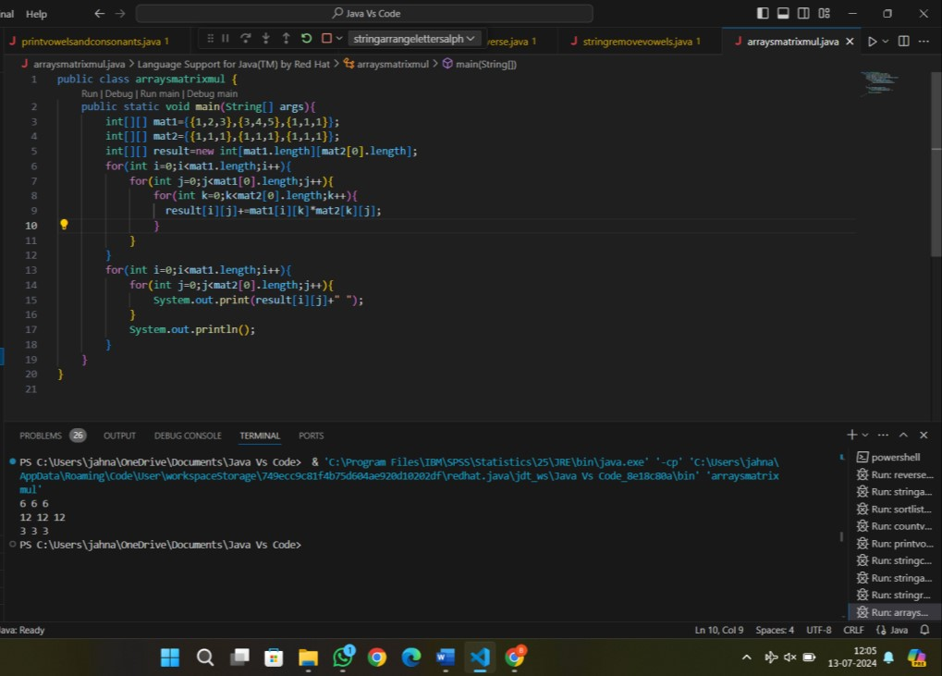

1. Write a program for matrix addition?

Sample Input:

Mat1 = 1 2

5 3

Mat2 = 2 3 4 1

Sample Output:

Mat Sum = 3 5

9 4

OUTPUT:

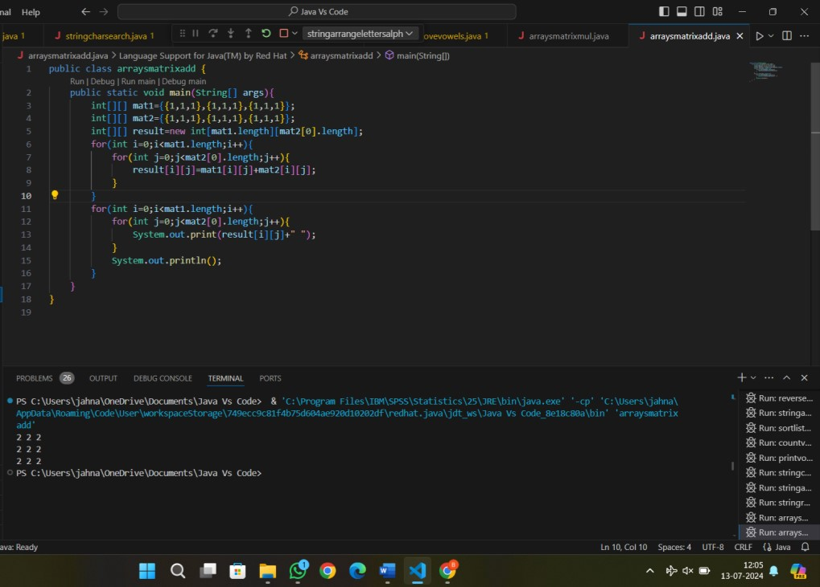

1. Write a program for Merge two sorted arrays using Array list

Input: arr1[] = { 1, 3, 4, 5}, arr2[] = {2, 4, 6, 8}

Output: arr3[] = {1, 2, 3, 4, 4, 5, 6, 8}

OUTPUT:

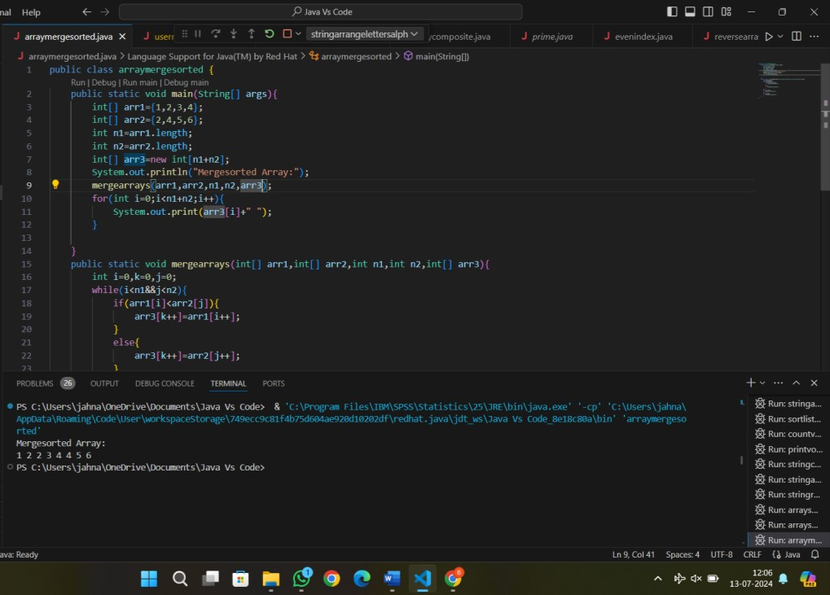

1. Find the Mean, Median, Mode of the array of numbers? Sample Input;:

Array of elements = {16, 18, 27, 16, 23, 21, 19} Sample Output:

Mean = 20

Median = 19

Mode = 16 Test cases:

* + 1. Array of elements = {26, 28, 37, 26, 33, 31, 29}
    2. Array of elements = {1.6, 1.8, 2.7, 1.6, 2.3, 2.1, .19}
    3. Array of elements = {0, 160, 180, 270, 160, 230, 210, 190, 0}
    4. Array of elements = {200, 180, 180, 270, 160, 270, 270, 190, 200}
    5. Array of elements = {100, 100, 100, 100, 100, 100, 100, 100, 100}

CODE:

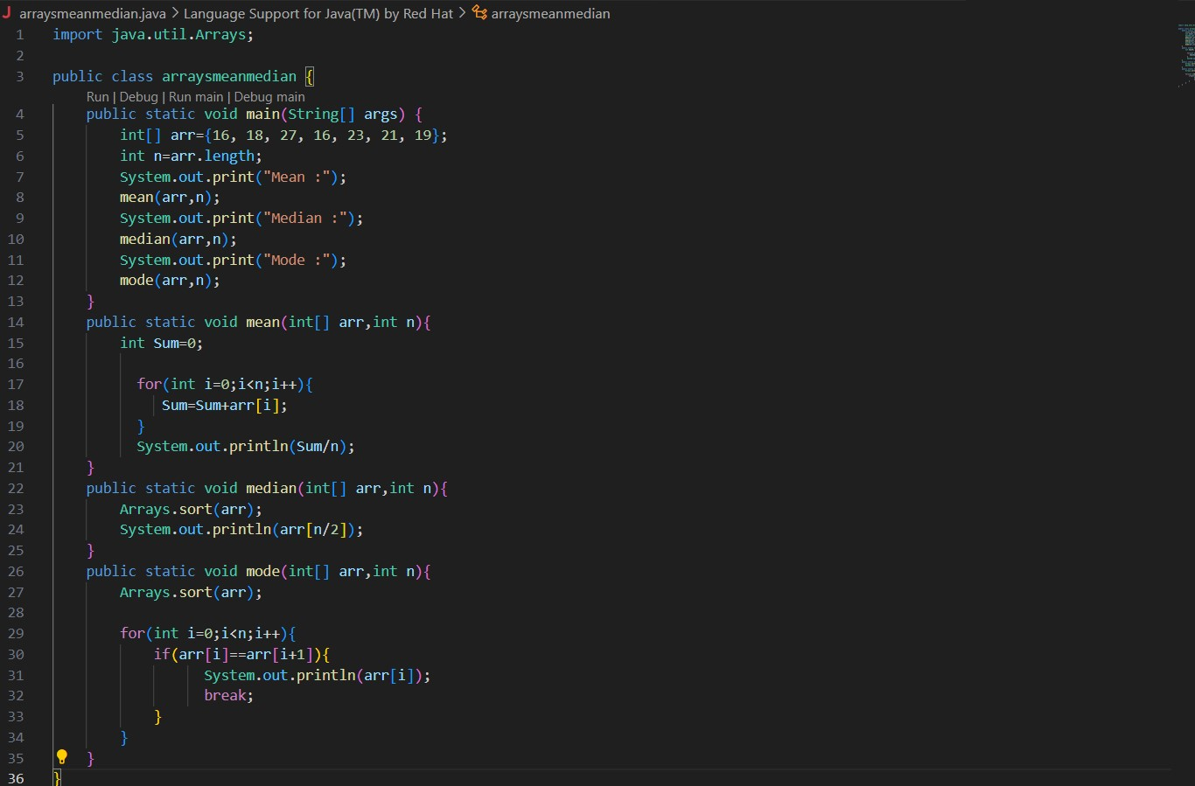

OUTPUT:



1. Write a program to find the number of composite numbers in an array of elements Sample Input;:

Array of elements = {16, 18, 27, 16, 23, 21, 19} Sample Output:

Number of Composite Numbers = 5 Test cases:

* + 1. Array of elements = {26, 28, 37, 26, 33, 31, 29}
    2. Array of elements = {1.6, 1.8, 2.7, 1.6, 2.3, 2.1, .19}
    3. Array of elements = {0, 160, 180, 270, 160, 230, 210, 190, 0}
    4. Array of elements = {200, 180, 180, 270, 270, 270, 190, 200}
    5. Array of elements = {100, 100, 100, 100, 100, 100, 100, 100}

OUTPUT:

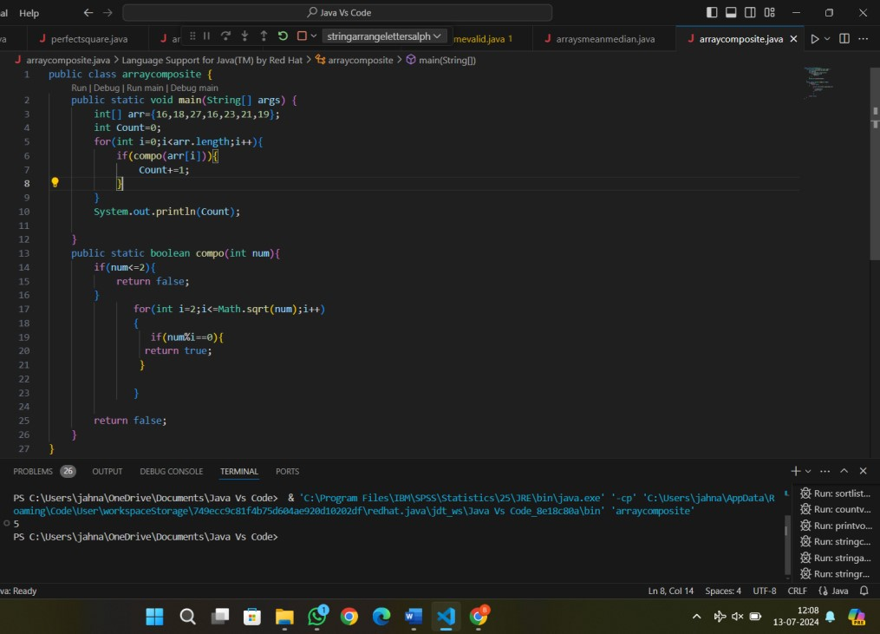

**Patterns :**

1. Write a program to print Right Triangle Star Pattern Sample Input:: n = 5 Output:

*

* + - * + *
        + * *
        + * * *
        + * * * *

OUTPUT:

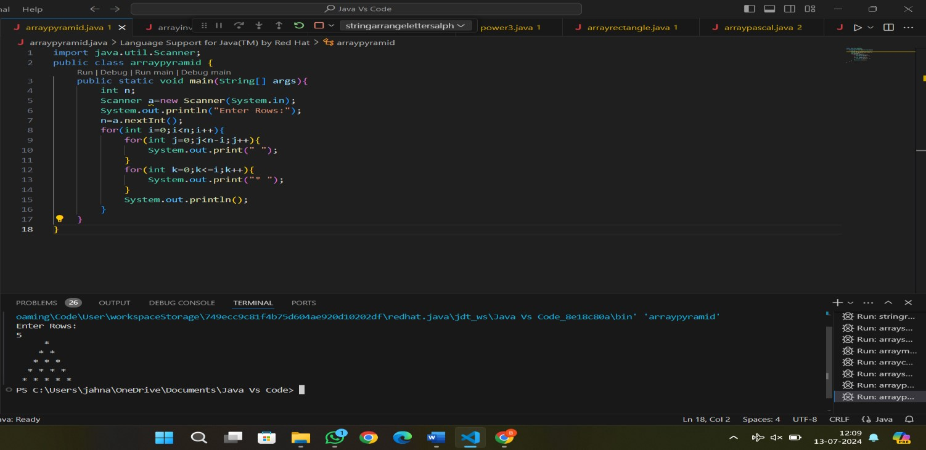

1. Write a program to print the below pattern?

1

1 1

1 2 1

1 3 3 1

1 4 6 4 1

**OUTPUT:**

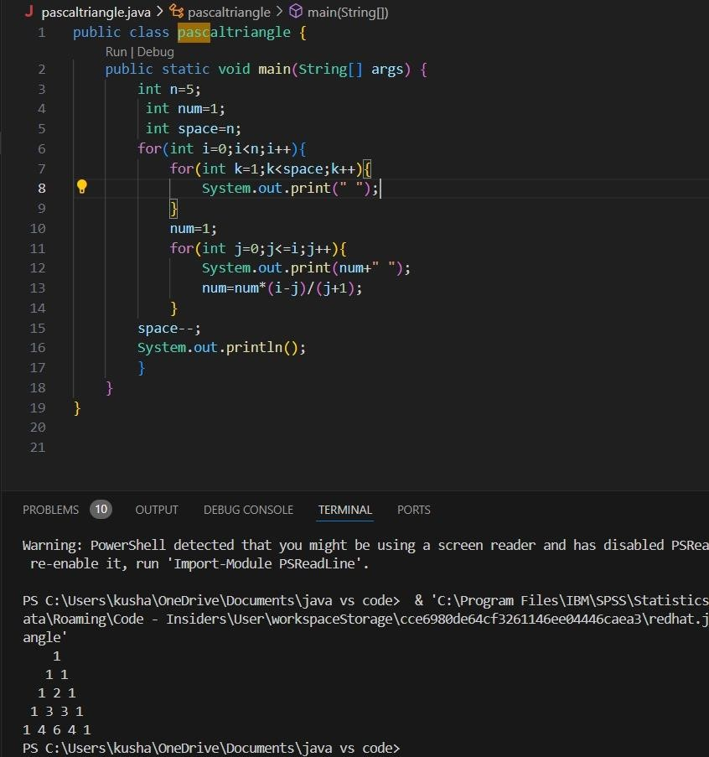

1. Write a program to print rectangle symbol pattern. Get the symbol as input from user

OUTPUT:

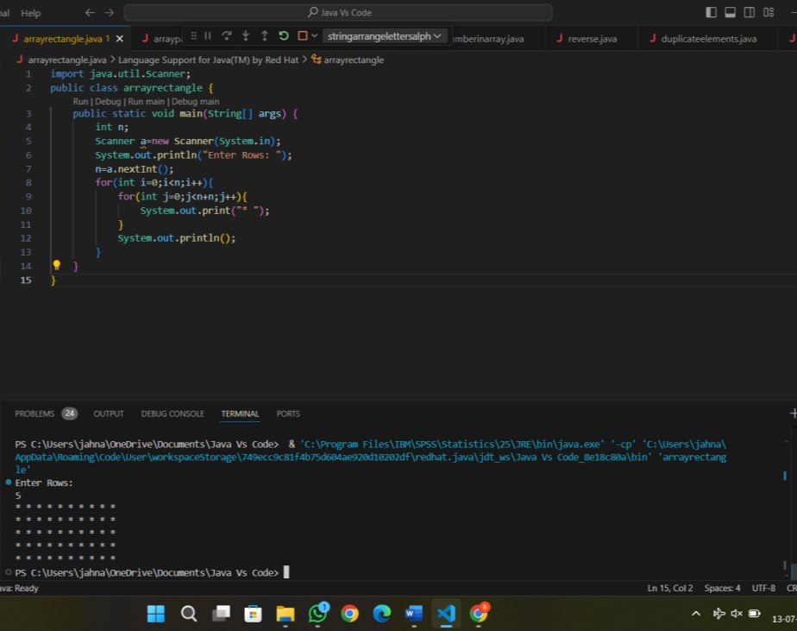

1. Write a program to print the following pattern Sample Input:

Enter the number to be printed: 1

Max Number of time printed: 3

1

11

111

11

1

**OUTPUT:**

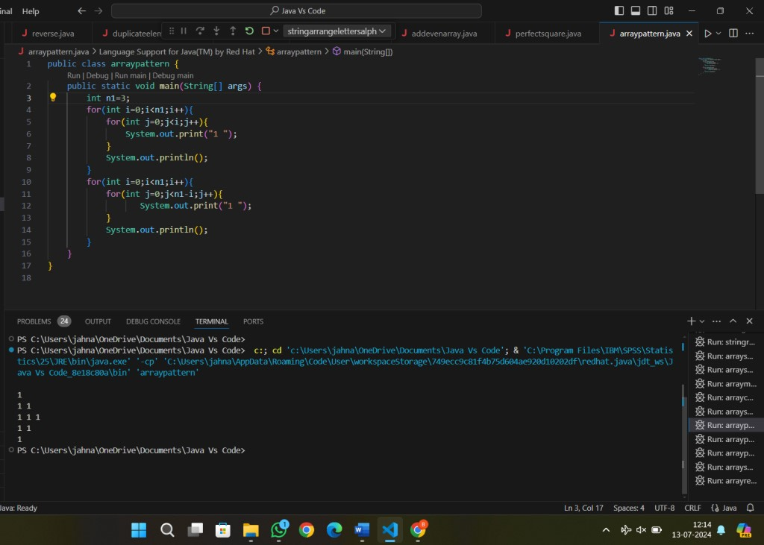

1. Write a program to print the Inverted Full Pyramid pattern?

OUTPUT:

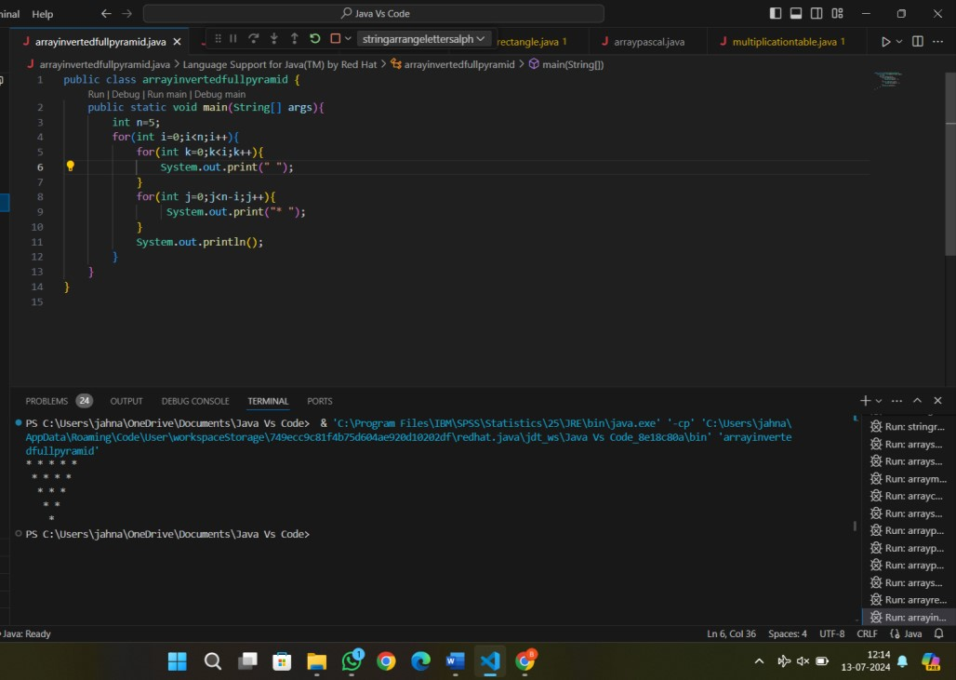

**ASSIGNMENT-3**

1. Write a program to print the following pattern Sample Input:

Enter the Character to be printed: %

Max Number of time printed: 3

%

% %

% % %

**OUTPUT:**

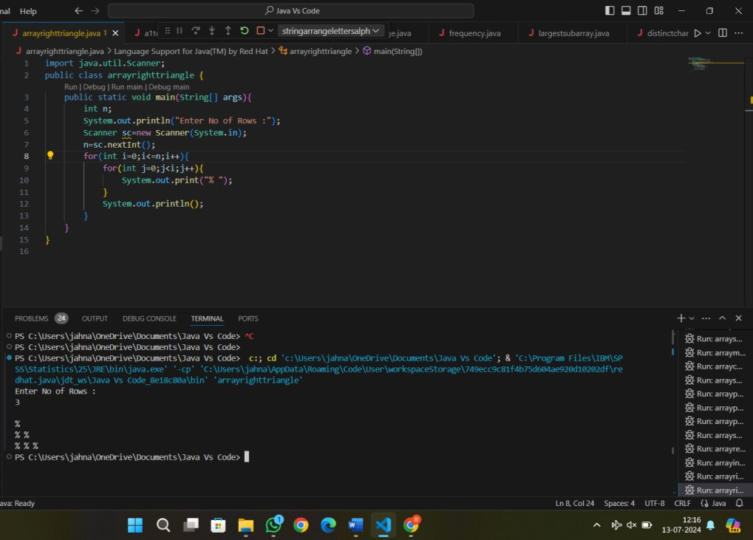

1. Write a program to print hollow square symbol pattern?

OUTPUT:

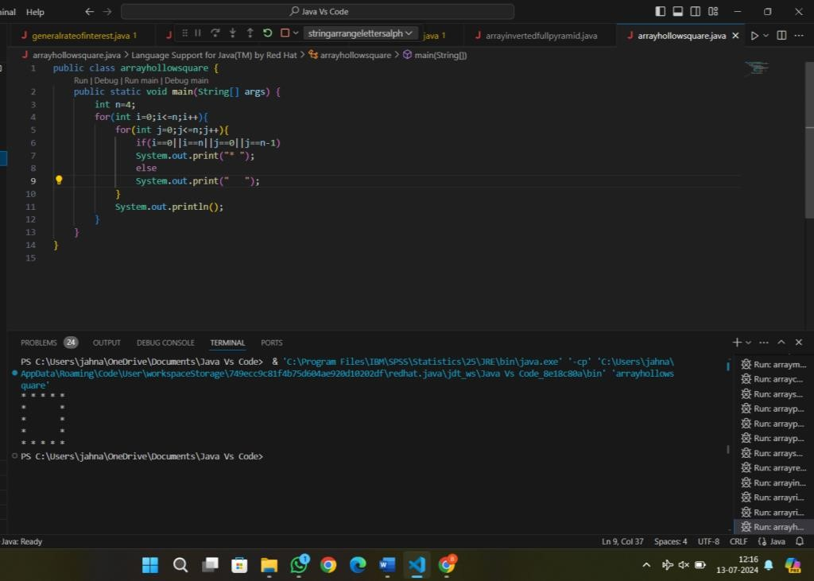

1. Write a program to print the below pattern

1

* 1. 2
  2. 3 3

# 4 4 4 4

OUTPUT:

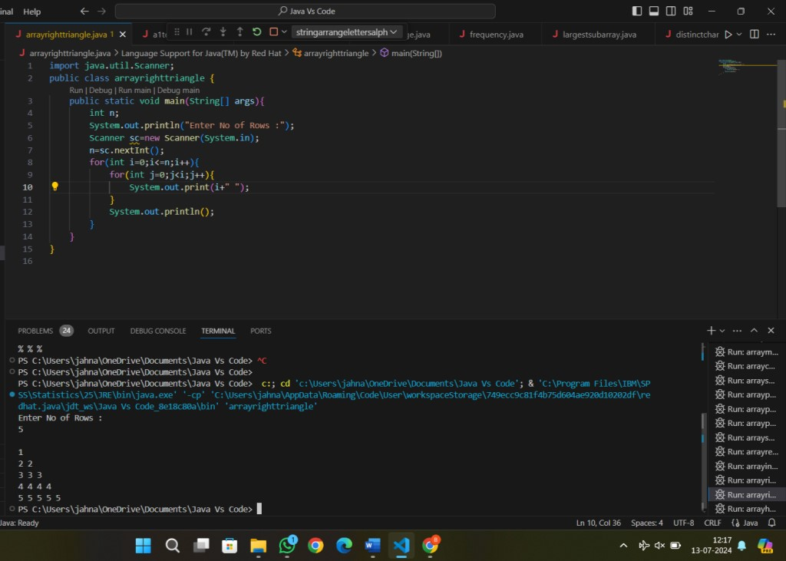

1. Write a program to print the below pattern

1

4 9

16 25 36

49 64 81 100

OUTPUT:

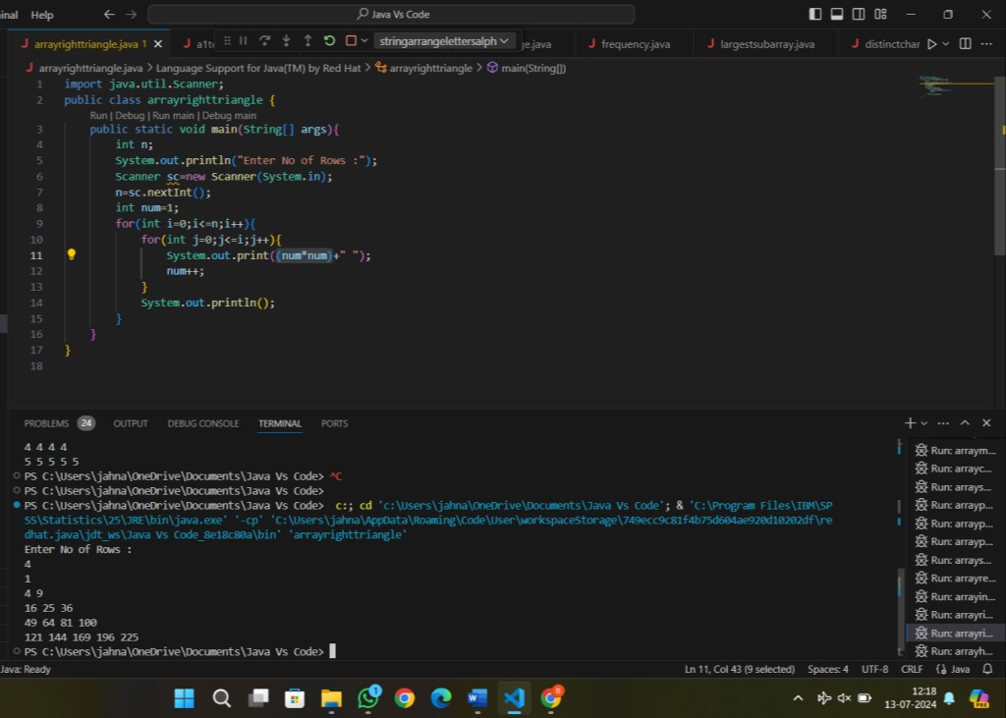

1. Write a program to print the below pattern

1

2 2

3 3 3

4 4 4 4

3 3 3

2 2

1

OUTPUT:

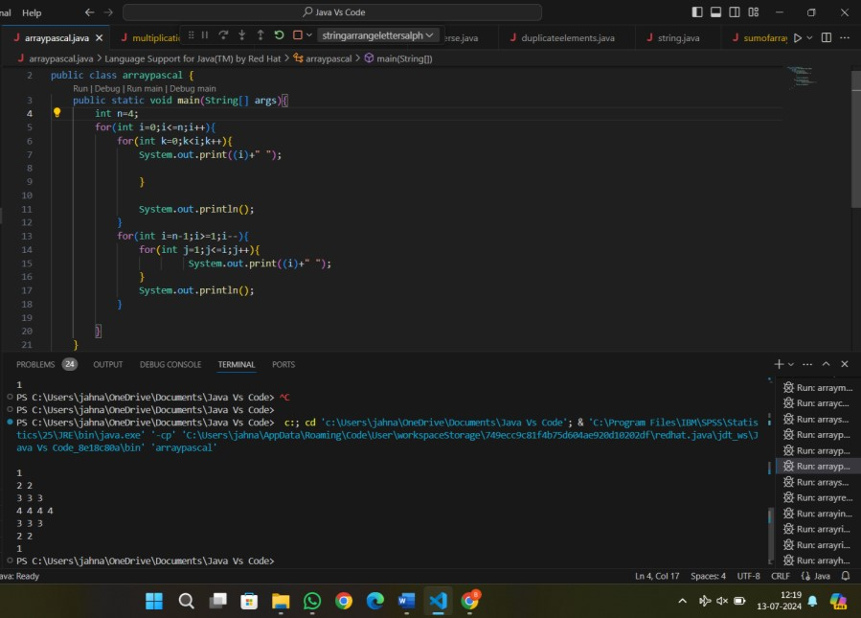

1. Write a program to print hollow Square Dollar pattern?

OUTPUT:

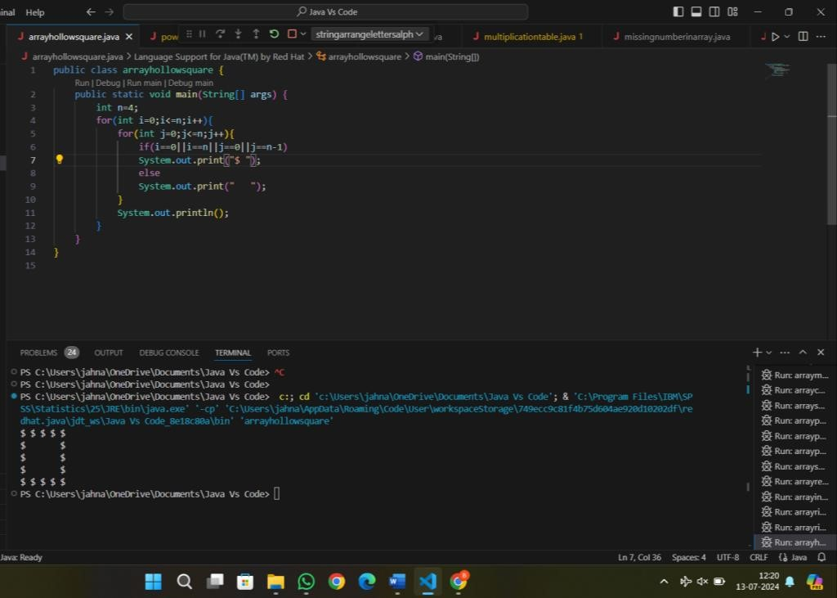

1. Write a program to print inverted pyramid pattern.

Input: no of rows: 3 Output

*****

***

* **OUTPUT:**

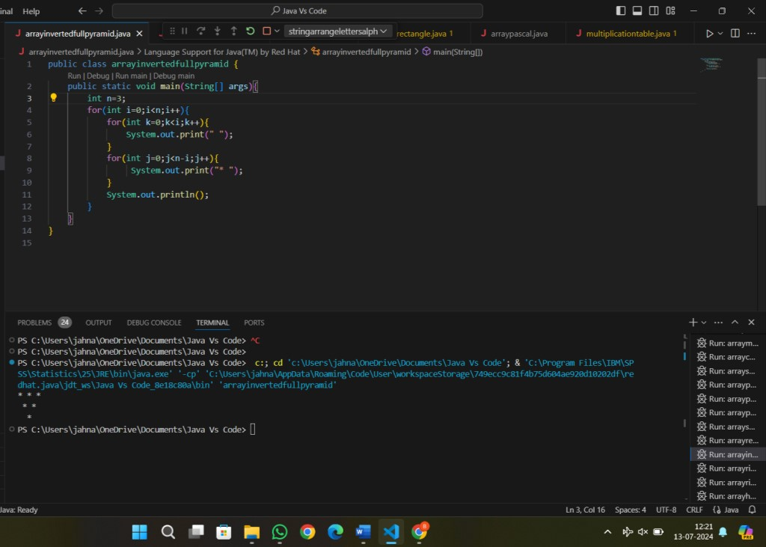

**General:**

1. Write a program to reverse a number using loop?(Get the input from user) Sample Input:

Number: 14567 Sample Output:

Reverse Number: 76541 Test cases:

* 1. -45721
  2. 000
  3. AD1947
  4. !@#$%
  5. 145*999=144855

OUTPUT:

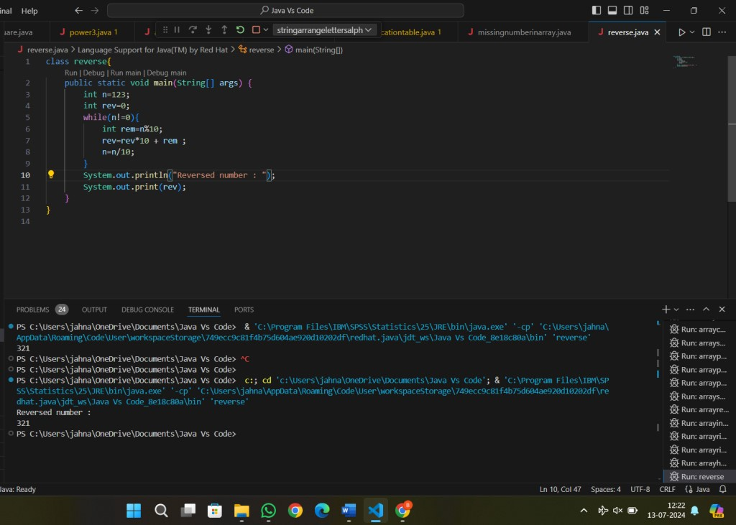

1. Write a program to convert the given decimal to binary and print the reverse of the binary decimal. Input: 11

Output: 13

Explanation: (11)10 = (1011)2.

After reversing the bits we get:

(1101)2 = (13)10.

Test cases:

* 1. 25
  2. Eighteen
  3. 12
  4. -18
  5. 34.5

OUTPUT:

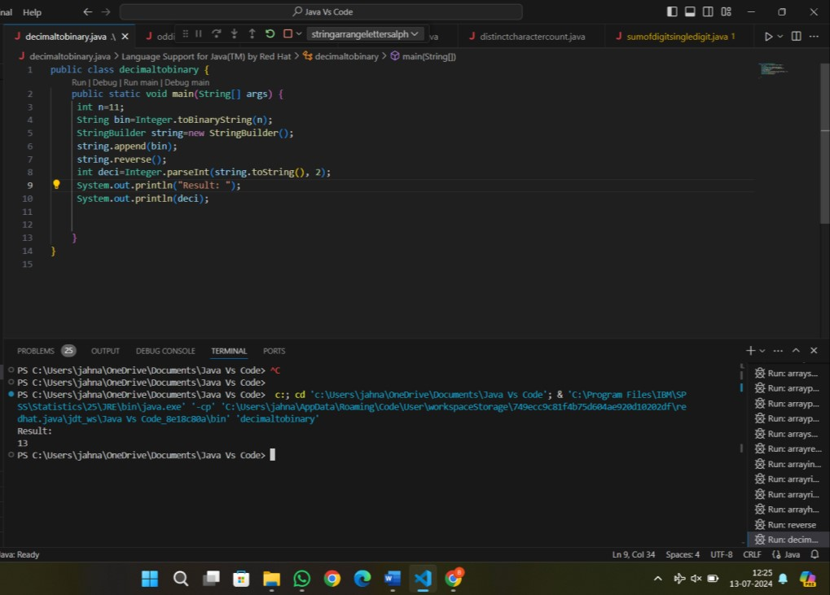

**ASSIGNMENT-4**

1. Write a program to find whether the person is eligible for vote or not. And if that particular person is not eligible, then print how many years are left to be eligible.

Sample Input:

Enter your age:7 Sample output:

You are allowed to vote after 11 years Test cases:

* 1. 25
  2. Eighteen
  3. 12
  4. -18
  5. 34.5

OUTPUT:

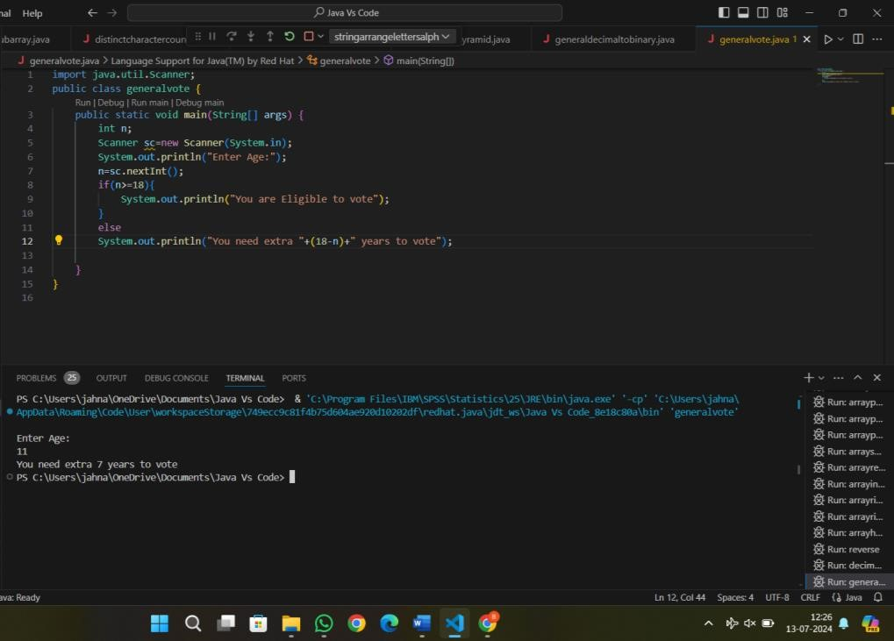

1. Find the LCM and GCD of n numbers?

Sample Input: N value = 2

Number 1 = 16

Number 2 = 20 Sample Output: LCM = 80

GCD = 4

Test cases:

* + 1. N = 3, {12, 25, 30}
    2. N = 2, {52, 25, 63}
    3. N = 3, {17, 19, 11}
    4. N = -2, {52, 60}
    5. N = 2, {30, 45}

OUTPUT:

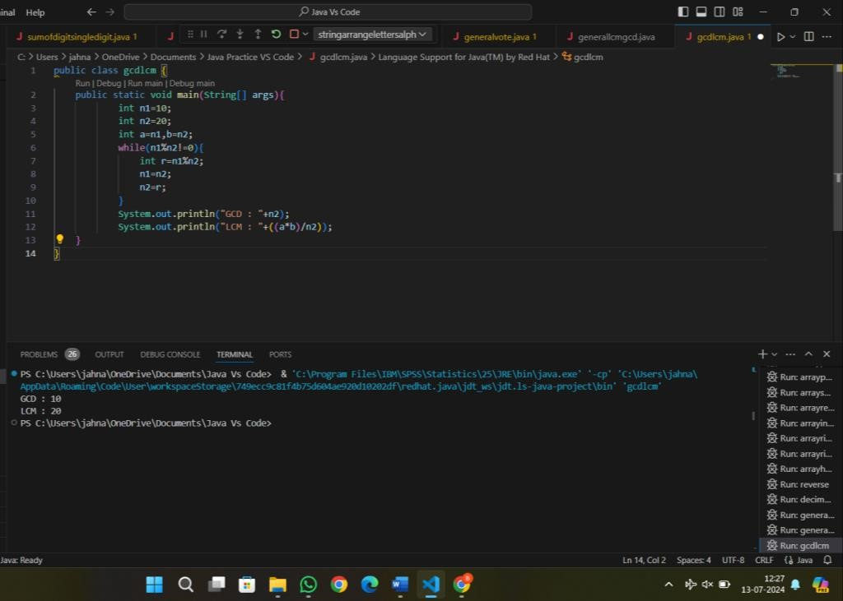

1. Write a program using function to calculate the simple interest. Suppose the customer is a senior citizen. He is being offered 12 percent rate of interest; for all other customers, the ROI is 10 percent.

Sample Input:

Enter the principal amount: 200000

Enter the no of years: 3

Is customer senior citizen (y/n): n Sample Output:

Interest: 60000 Test Cases:

* + 1. Principal: 2000 , Years: 0
    2. Principal: 20000 , Years: -2
    3. Principal: -2000 , Years: 2
    4. Principal: 2 , Years: 2000
    5. Principal: 0 , Years: 5

OUTPUT:

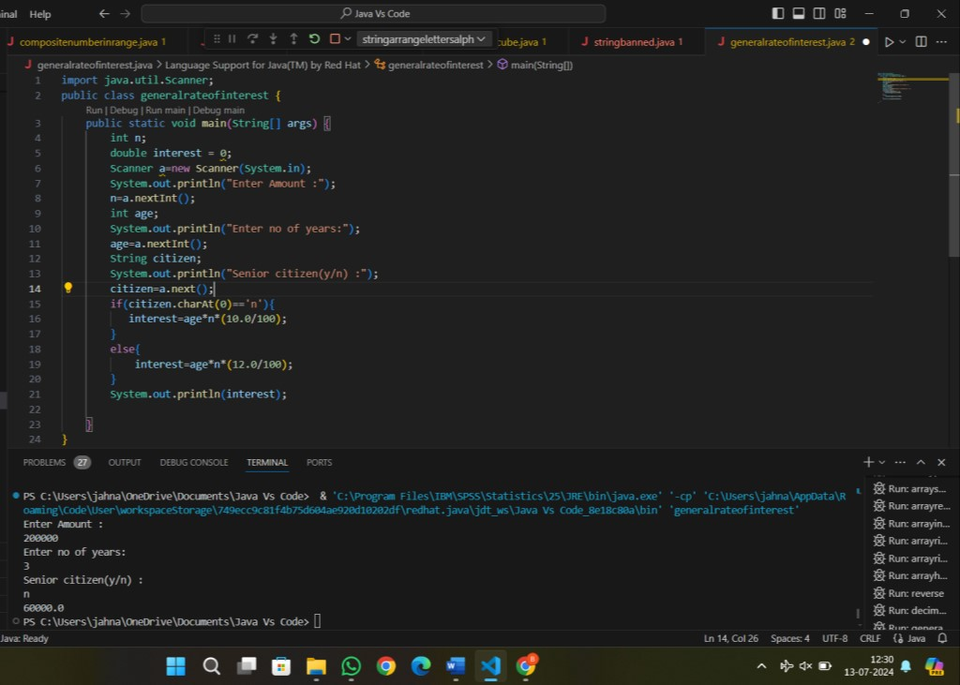

1. Write a program to print the Fibonacci series.

Sample Input:

Enter the n value: 6 **Sample Output:**

0 1 1 2 3 5

OUTPUT:

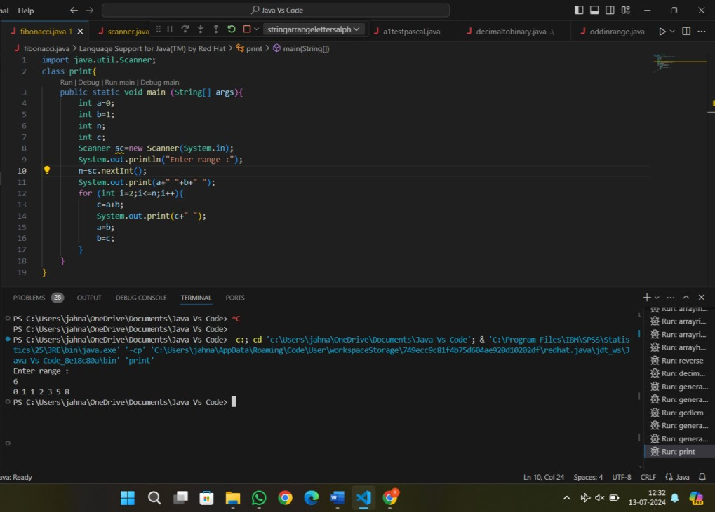

1. [Java Program to Find Even Sum of Fibonacci Series Till number N?](https://www.geeksforgeeks.org/java-program-to-find-sum-of-fibonacci-series-numbers-of-first-n-even-indexes/)

Sample Input: n = 4 Sample Output: 33

(N = 4, So here the fibonacci series will be produced from 0th term till 8th term:0, 1, 1, 2, 3, 5, 8, 13, 21

Sum of numbers at even indexes = 0 + 1 + 3 + 8 + 21 = 33)

CODE:

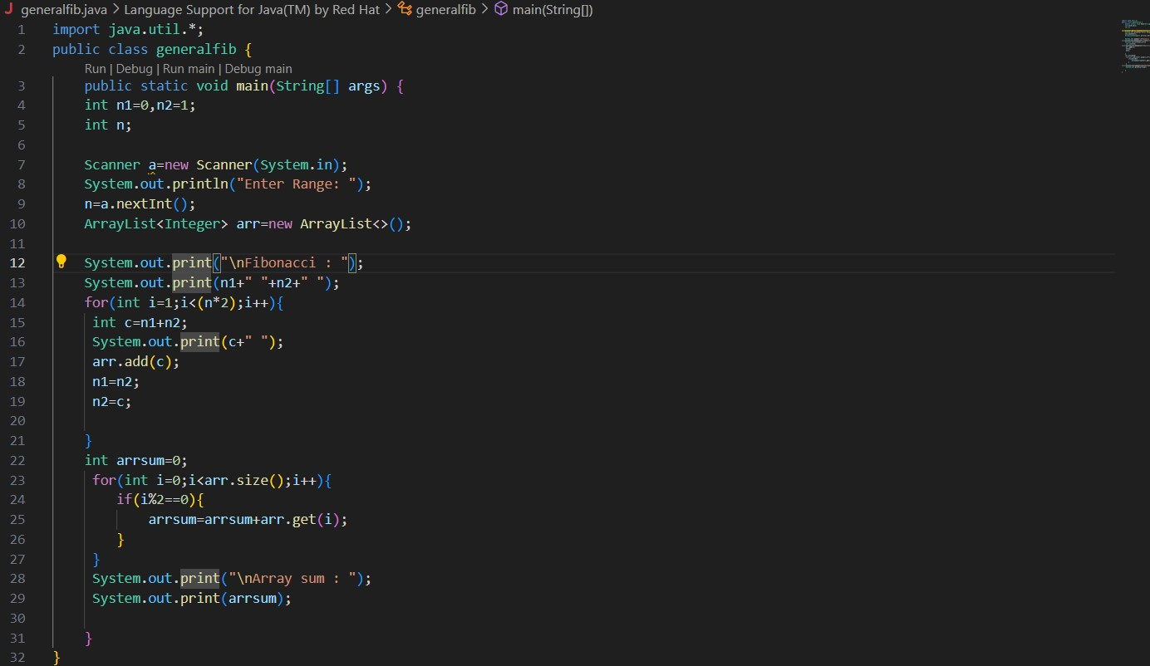

OUTPUT:

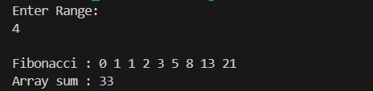

1. Write a program to print the numbers from M to N by skipping K numbers in between? Sample Input: M = 50

N = 100

K = 7

Sample Output: 50, 58, 66, 74, ….. Test cases:

* + 1. M = 15, N = 05, K = 02
    2. .M = 25, N = 50, K = 04
    3. M = 15, N = 100, K = -02
    4. M = 0 , N = 0 , K = 2
    5. M = 200 , N = 200 , K = 50

OUTPUT:

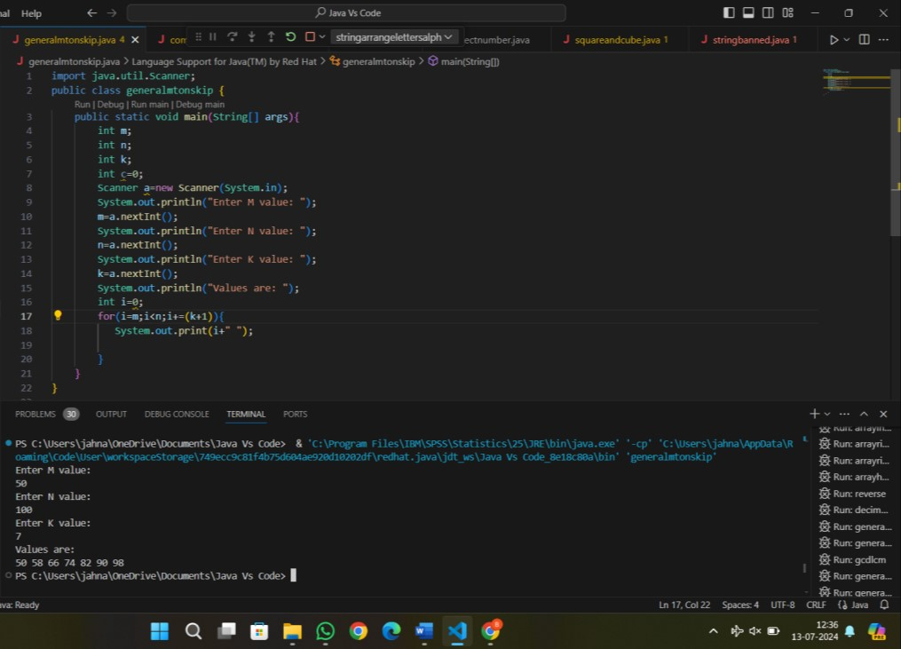

1. Write a program to print all the composite numbers between a and b?

Sample Input: A = 12

B = 19

Sample Output

14, 15, 16, 18 Test cases:

* + 1. A = 11, B = 11
    2. A = 20, B = 10
    3. A = 0, B = 0
    4. A = -5, B = 5
    5. A = 7, B = -12

CODE:

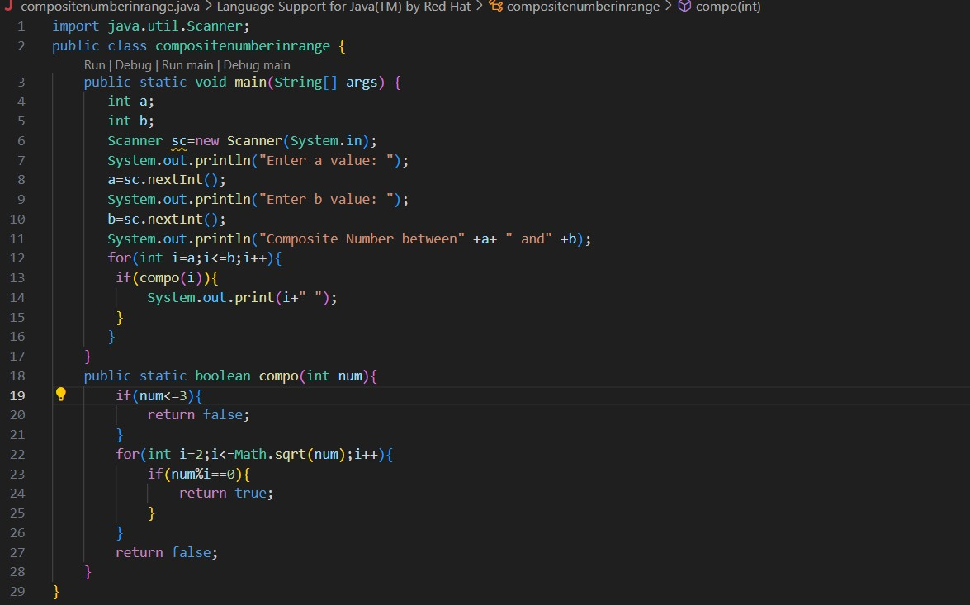

OUTPUT:

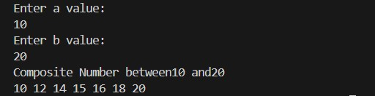

1. Find the factorial of n? Sample Input: N = 4 Sample Output:

4 Factorial = 24 Test cases:

* + 1. N = 0
    2. N = -5
    3. N = 1
    4. N = Q
    5. N = 3A

OUTPUT:

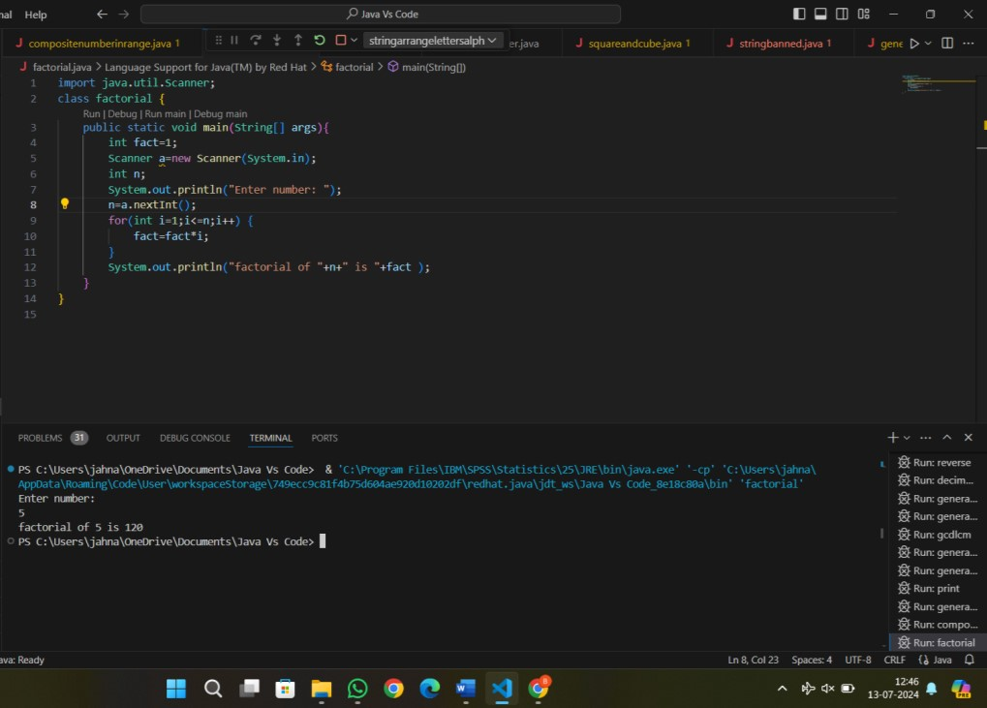

1. Find the year of the given date is leap year or not Sample Input:

Enter Date: 04/11/1947 Sample Output:

Given year is Non Leap Year Test cases:

* + 1. 04/11/19.47
    2. 11/15/1936
    3. 31/45/1996
    4. 64/09/1947
    5. 00/00/2000

OUTPUT:

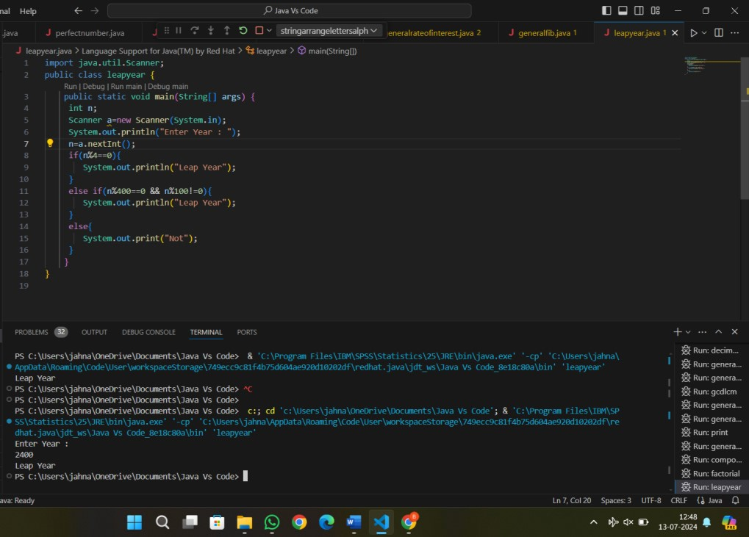

1. Find the number of factors for the given number Sample Input:

Given number: 100

Sample Output:

Number of factors = 9 Test cases:

* + 1. 343
    2. 1080
    3. -243
    4. 101010
    5. 0

OUTPUT:

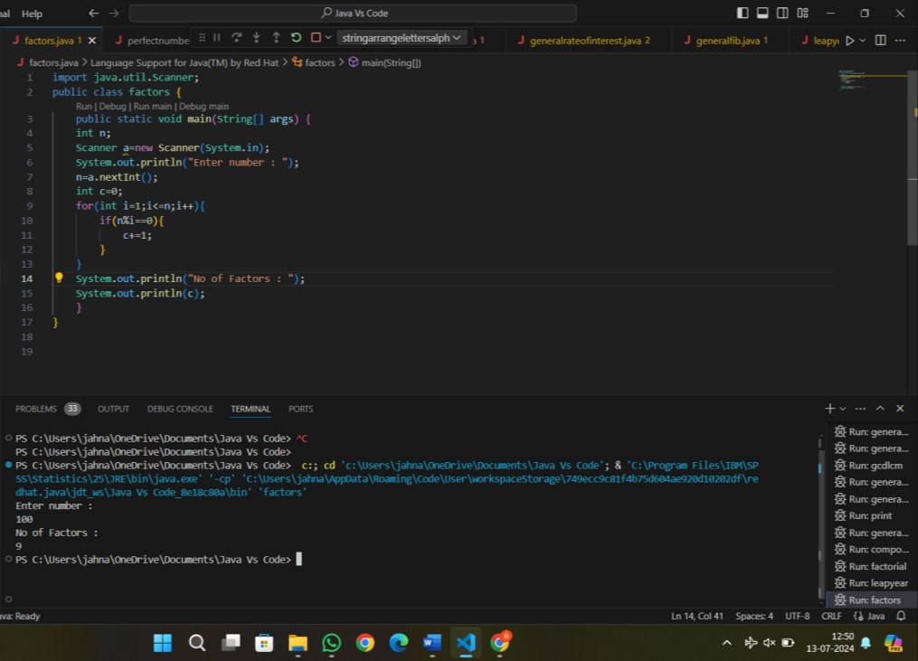

1. Write a program to print the given number is Perfect number or not?

Sample Input:

Given Number: 6 Sample Output:

It’s a Perfect Number Test cases:

* + 1. 17
    2. 26!
    3. 143
    4. 84.1
    5. -963

OUTPUT:

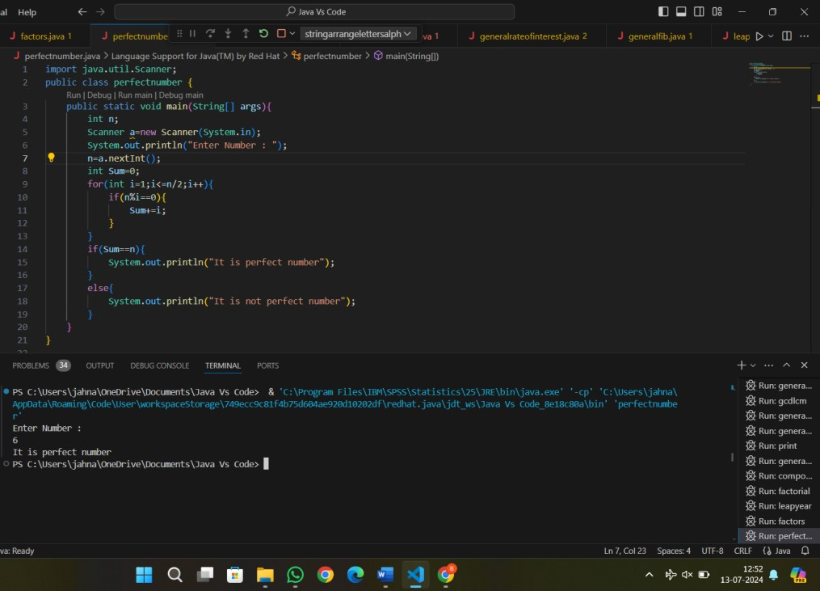

1. Write a program to find the square, cube of the given decimal number

Sample Input: Given Number: 0.6 Sample Output:

Square Number: 0.36

Cube Number:0.216 Test cases:

1. 12
2. 0
3. -0.5
4. 14.25
5. -296

OUTPUT:

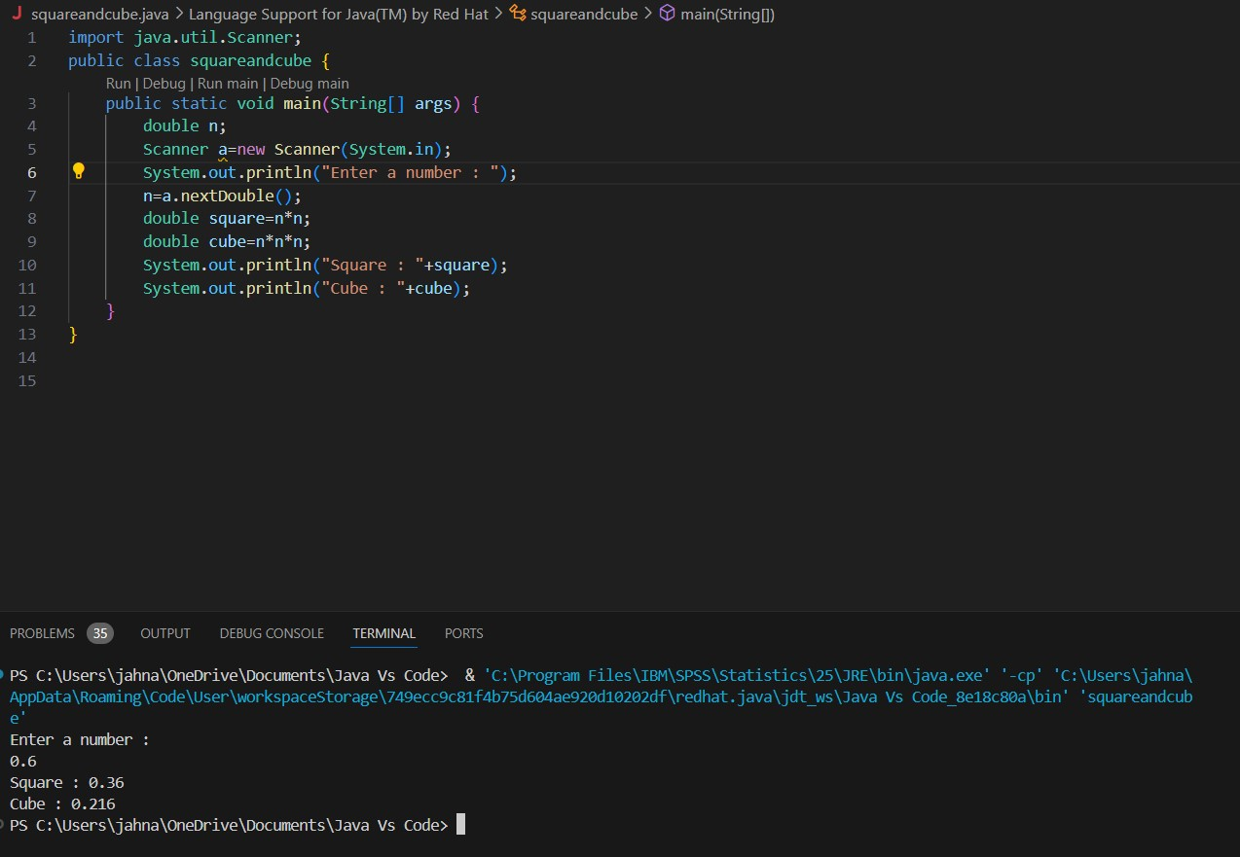

42.Find the nth odd number after n odd number Sample Input: N : 7 Sample Output:

Hence the values printed for i are 1 , 3 , 5.

Test cases:

1. N = 0
2. N = -6
3. N = 2021
4. N = -14.5
5. N = -196

CODE:

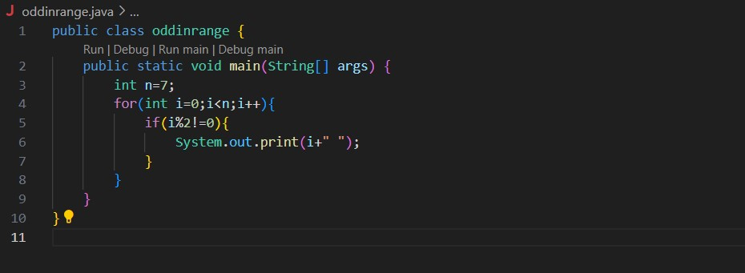

OUTPUT:



43. Program to find the frequency of each element in the array.

Sample Input & Output:

{1, 2, 8, 3, 2, 2, 2, 5, 1} **Pseudo**:

Element | Frequency

-------------------------- 1 | 2

2 | 4

8 | 1

1. | 1
2. | 1

CODE:

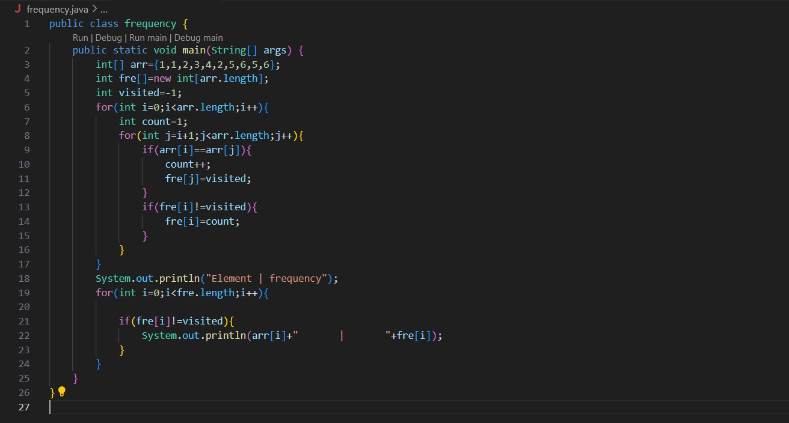

OUTPUT:

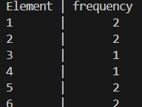

44. Program to find whether the given number is Armstrong number or not

Sample Input: Enter number: 153 Sample Output:

Given number is Armstrong number Test cases:

1. 370
2. 1
3. 371
4. 145678
5. 0.21345

CODE:

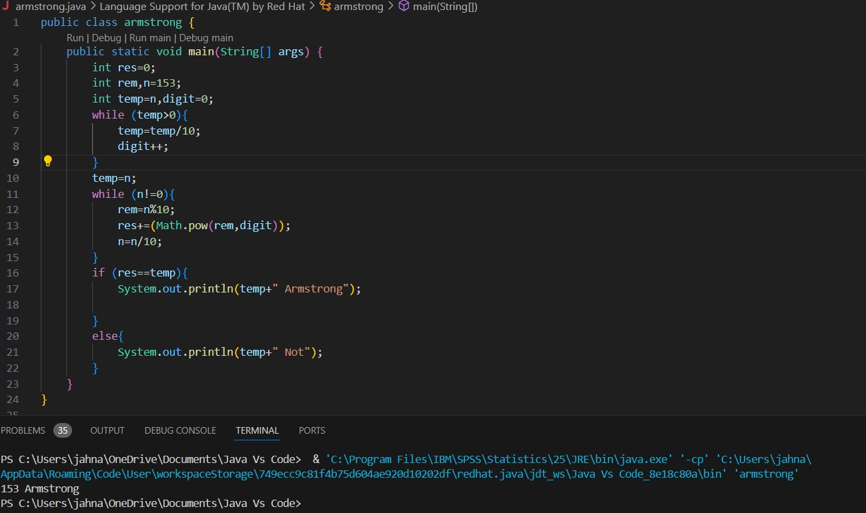

45. Write a program to find the sum of digits of N digit number (sum should be single digit)

Sample Input:

Enter N value: 3

Enter 3 digit numbers: 143 Test cases:

1. N = 2, 158
2. N = 3, 14
3. N = 4, 0148
4. N = 1, 0004
5. N = 4, 7263

CODE:

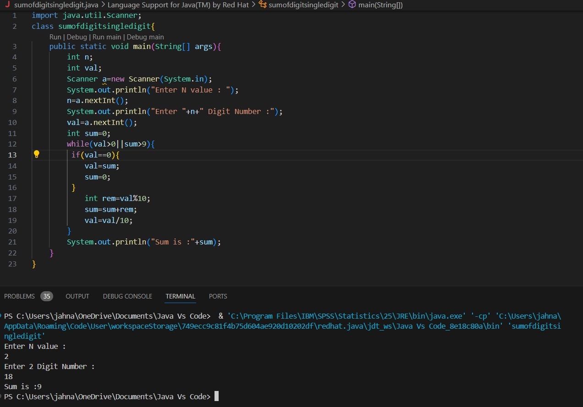

46. Write a program to find the square root of a perfect square number(print both the positive and negative values)

Sample Input: Enter the number: 6561 Sample Output: Square Root: 81, -81 Test cases:

1. 1225
2. 9801
3. 1827
4. -100
5. 0

OUTPUT:

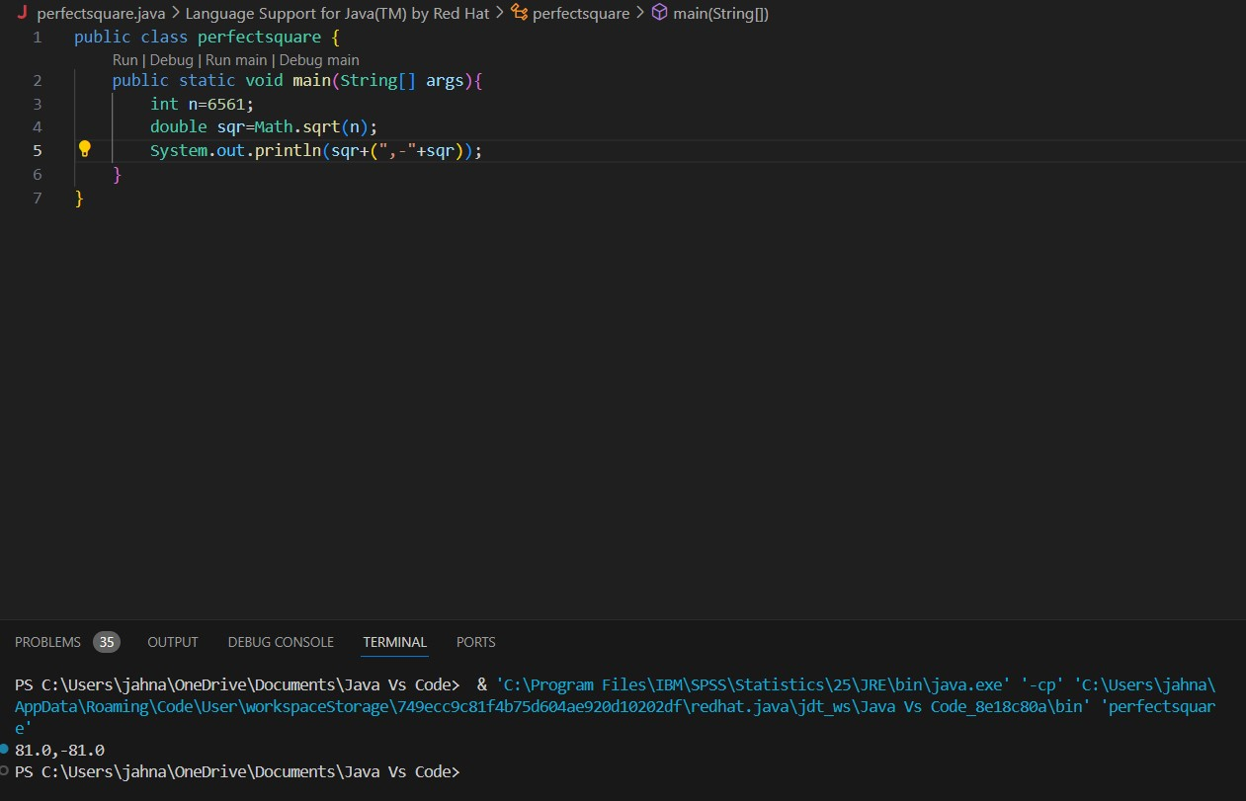

47. Write a program to given an integer n, return true if it is a power of three. Otherwise, return false.

Input =27 Output= true

Explanation: 27=33 Test cases: 1. 12

1. abc@45
2. 1827
3. -100
4. 0

OUTPUT:

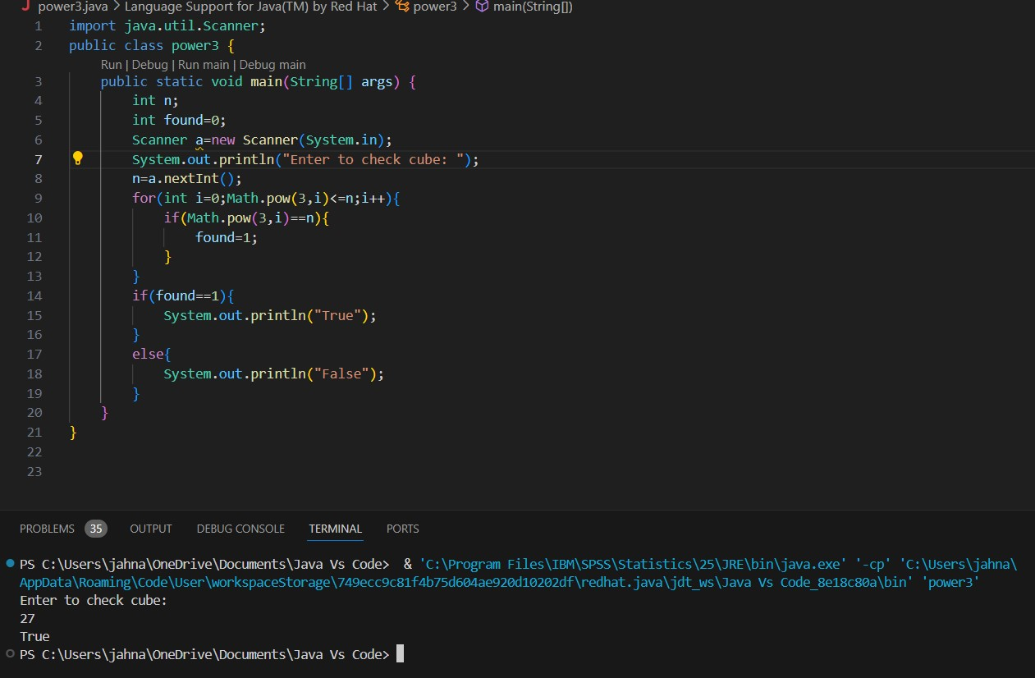

1. Write a program to given a fixed-length integer array arr, duplicate each occurrence of zero, shifting the remaining elements to the right.

Input: arr = [1, 0, 2, 3, 0, 4, 5, 0]

Output: [1, 0, 0, 2, 3, 0, 0, 4]

Explanation: After calling your function, the input array is modified to [1, 0, 0, 2, 3, 0, 0, 4]

OUTPUT:

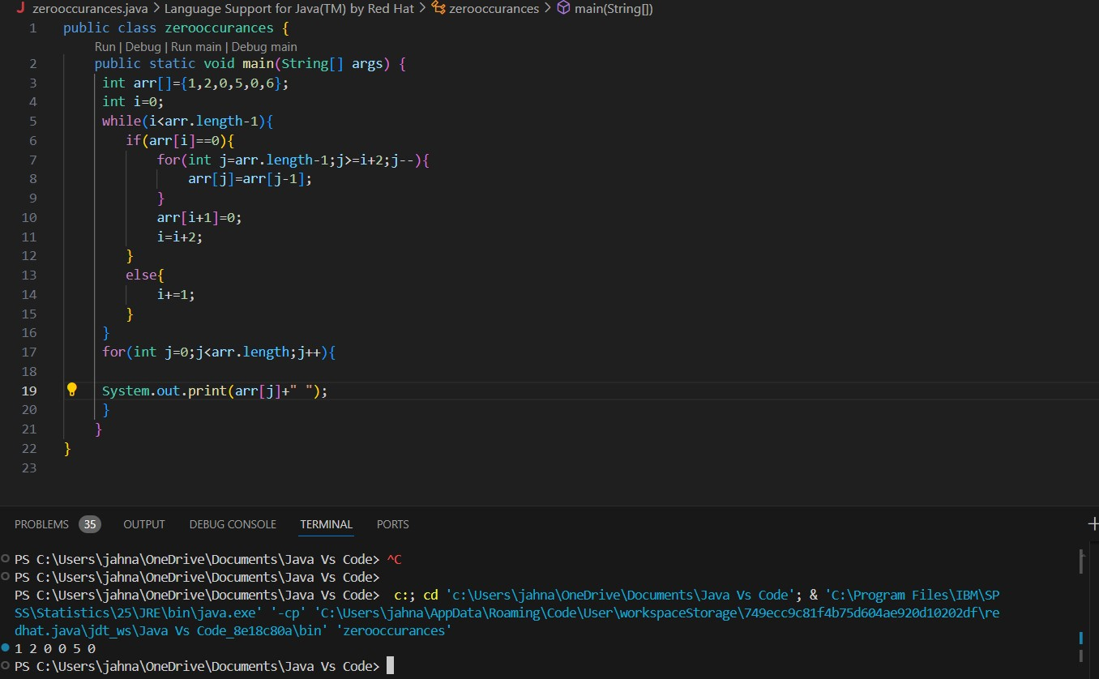

1. Write a program to given an array nums containing n distinct numbers in the range [0, n], return the only number in the range that is missing from the array.

Input nums = [3, 0, 1]

Output: 2

Explanation: n = 3 since there are 3 numbers, so all numbers are in the range [0, 3]. 2 is the missing number in the range since it does not appear in nums.

OUTPUT:

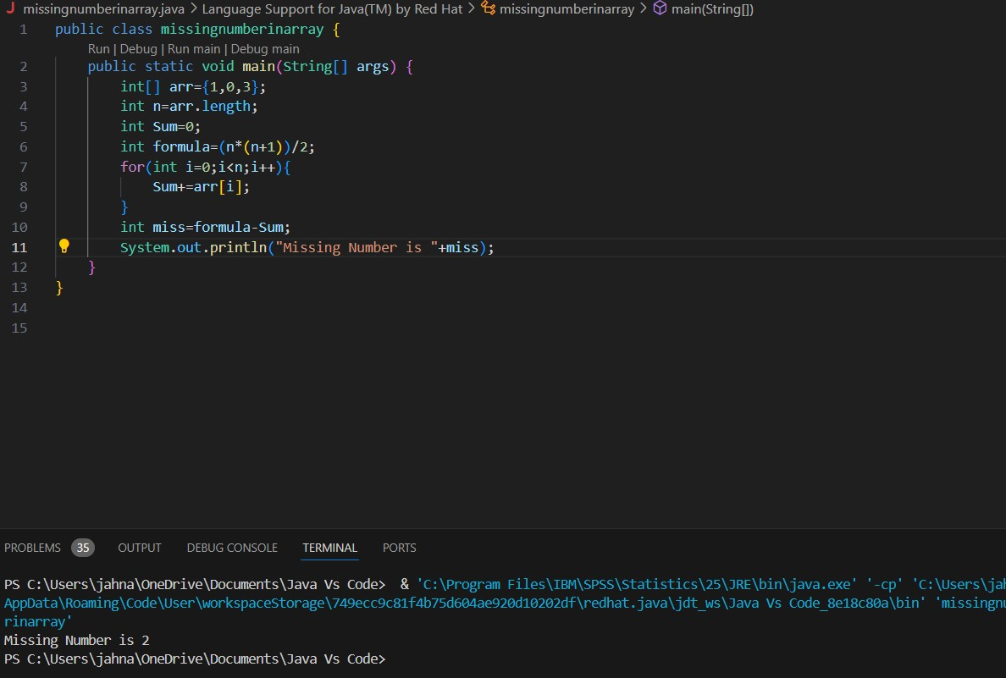

1. Write a program to given an integer array nums, find the subarray with the largest sum, and return its sum.

Input nums = [-2, 1,-3, 4,-1, 2, 1,-5, 4]

Output: 6

Explanation: The subarray [4,-1, 2, 1] has the largest sum 6.

OUTPUT:

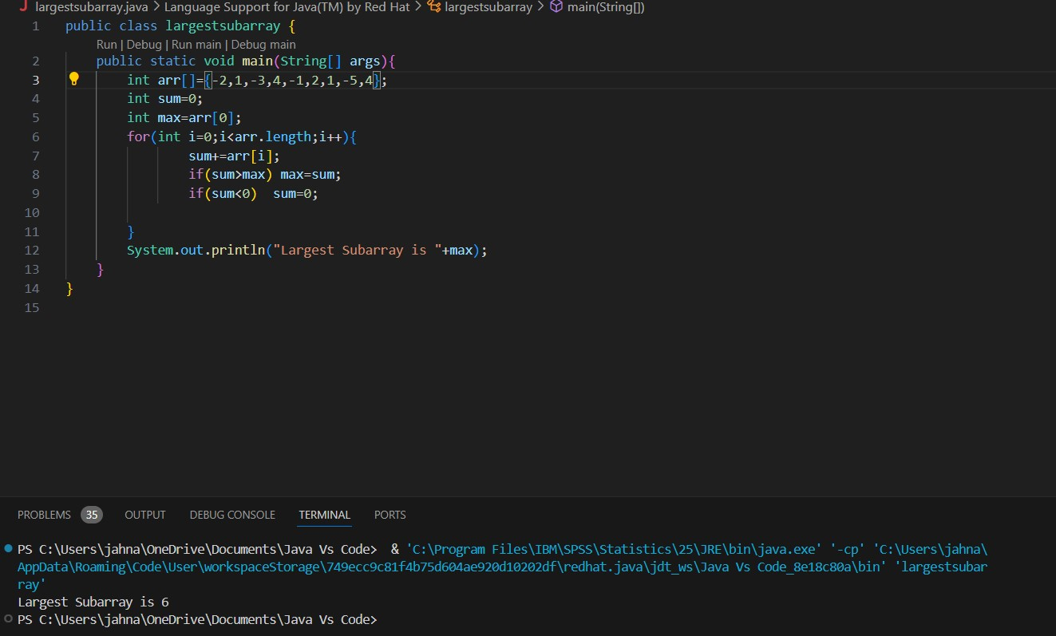

1. Write a program to print the multiplication table of number m up to n. Sample Input:
2. = 4
3. = 5

Sample Output:

1x4=4

2x4=8

3x4=12

4x4=16

5x4=20

Test cases:

M = 6, N = -3

M = -3, N = 5

M = 4, N = 0

M = 0, N = 0

M = -5, N = -5

OUTPUT:

